

**BIM423 – SOFTWARE ENGINEERING**

**2022-2023 FALL SEMESTER**

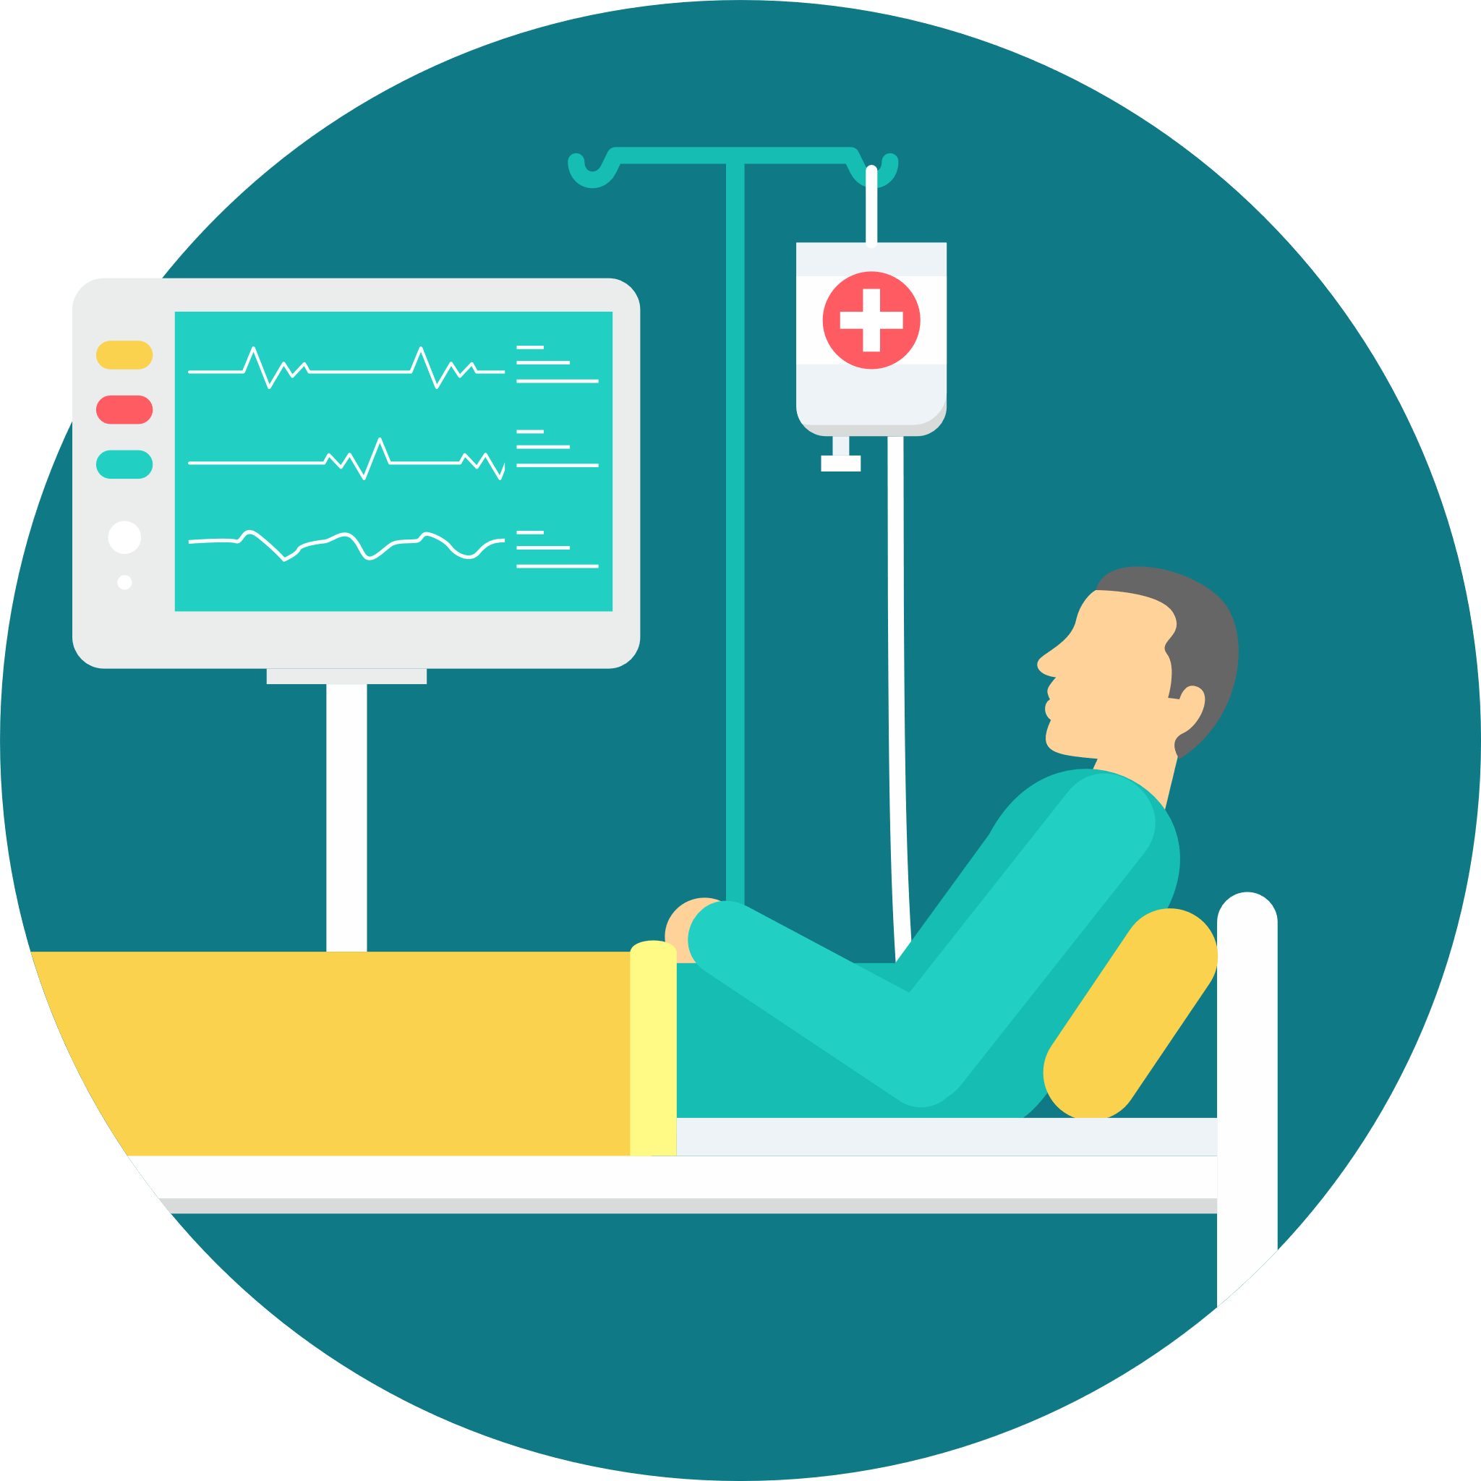

**Virtual Patent**

**Group 12**

**Week 6-7-8 / 7.11.2022 – 26.11.2022**

# Members

1. ***Uğur Dindar***
2. ***Emre Kayacık***
3. ***İdris Can Bölükbaşı***
4. ***Oğuzhan Çetin***
5. ***Umutcan Yavuz***
6. ***Yunus Emre Korkmaz***

# Links

* ***GitHub Link: https://github.com/VPatient***
* ***Website Link: https://vpatient.github.io/***
* ***Repo Link: https://github.com/orgs/VPatient/repositories***

# Works Done

* Patient laboratory results, patient blood sugar trace, patient norton pressure ulcer, patient medicine, patient vital sign, patient fall risk form, patient fall risk factors, patient diagnosis endpoints have been created. Code refactoring has been done.

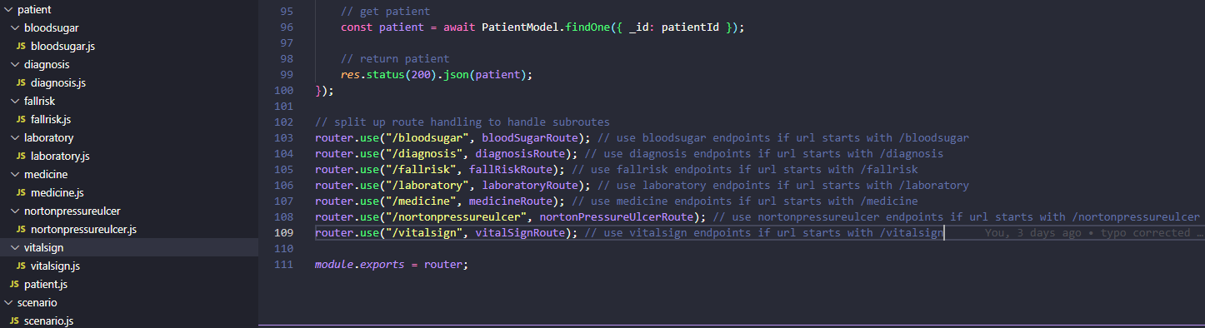

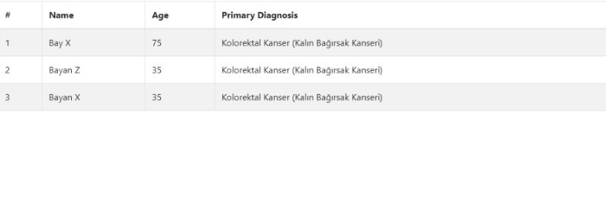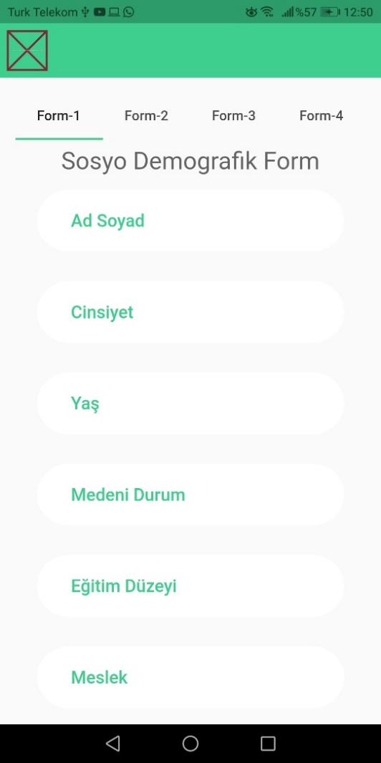

# Task Distribution

* ***Emre Kayacık: Created patient fall risk form, patient fall risk factors, patient diagnosis endpoints. Code refactoring has been done.***
* ***Uğur Dindar: Created patient laboratory results, patient blood sugar, patient Norton pressure ulcer, patient medicine, patient vital sign endpoints.***
* ***İdris Can Bölükbaşı: Unnecessary validation at login/register screens removed. Added animation to list at Select Patient Screen. Chat Simulation Screen now working with live data. Started to develop combo box menu to select correct questions for nurse to provide healthier communication with patient.***
* ***Oğuzhan Çetin: UI overlay bug has been fixed. Started to implement forms (like social-demographic form) to use at Chat Simulation Screen.***
* ***Yunus Emre Korkmaz: Created tables and get patient data from API.***
* ***Umutcan Yavuz: Design login screen and dashboard pages.***

***Individual Contribution*** *(state as a percentage for each member, decide according to the contribution of the individual on that week. If a member does not have any contribution, please state)* Every single team done work of themselves. We can just say that every team contributed evenly to in behalf of progress of the project.

**Plans for the Following Week (separated team by team, one page each team)**

**Back-end Development Team:**

* Creating a comprehensive scenario end-to-end then implementing into the system.

**Back-end Development Team’s board:**

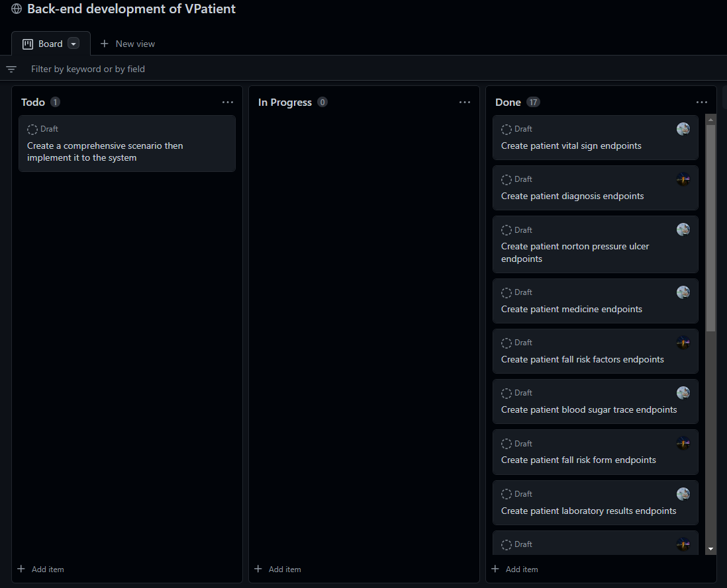

**Mobile Development Team:**

* Finished to develop necessary forms with validation.
* Chat screen will be fully developed.

**Mobile Development Team’s board:**

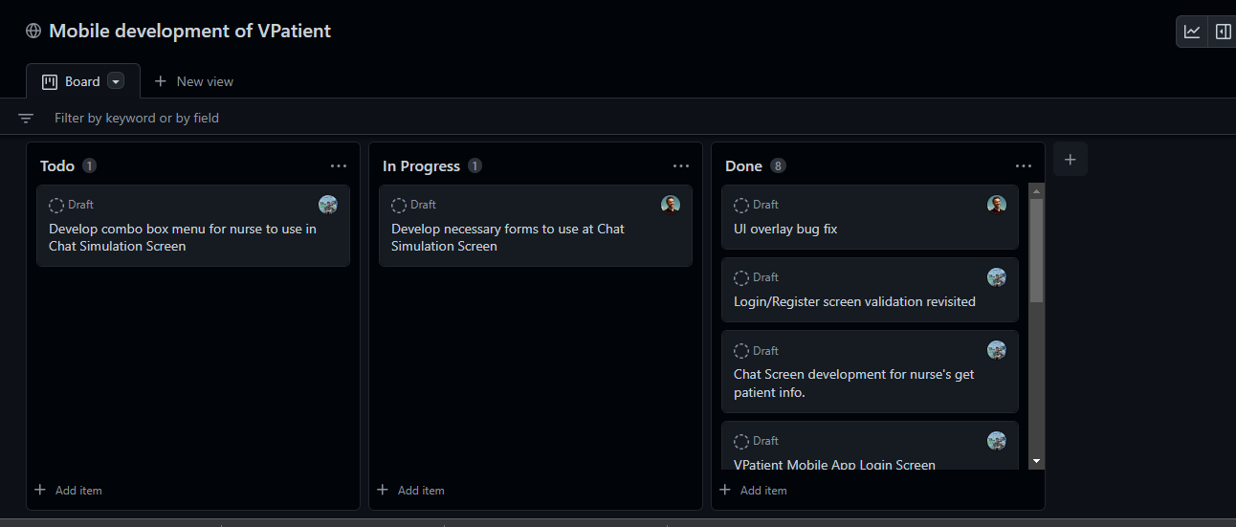

**Front-end Development Team:**

* **Use advanced table graphs**

**Front-end Development Team’s Board:**

